
CENTRAL BOARD OF SECONDARY EDUCATION


JAWAHAR NAVODAYA VIDYALAYA
TARIKHET ALMORA UTTARAKHAND 263663

COMPUTER SCIENCE (083)
PROJECT FILE
On
MYSQL-BASED STUDENT MANAGEMENT SYSTEM
SESSION: 2026-27
SUBMITTED BY :

S. No | Name | CBSE Roll
CLASS : XII
SECTION : SCIENCE

PRINCIPAL
(PANKAJ KUMAR SRIVASTAVA)

INTERNAL EXAMINER
(PANKAJ BHILINGWAL)

EXTERNAL EXAMINER

ACKNOWLEDGEMENT

I wish to express my deep sense of gratitude and indebtedness to our learned teacher Pankaj Bhilingwal, PGT Computer Science, J.N.V Tarikhet Almora for his invaluable help, advice and guidance in the preparation of this project file.
I am also greatly indebted to our principal Pankaj Kumar Srivastava and school authorities for providing me with the facilities and requisite laboratory conditions for making this project file.
I also extend my thanks to a number of teachers, my classmates and friends who helped me to complete this project file successfully.
NAME :

S. No | Name | CBSE Roll

CLASS : XII
SECTION : SCIENCE

CERTIFICATE

This is to certify that,
S. No | Name | CBSE Roll

Student of Class XII, J.N.V Tarikhet Almora has completed the PROJECT FILE during the academic year 2026-27 towards partial fulfilment of credit for the Computer Science Project evaluation of CBSE and submitted satisfactory report, as compiled in the following pages, under my supervision.

Internal Examiner External Examiner
Signature Signature

PREFACE

In the field of Computer Science, the term PROJECT refers to a Computerization Work that is completely performed by using a computer. Today when every field is going to be computerized means that all task of any field now a days done by using computer and their appropriate computer programs, then to do every field’s different-different works, today different programs or software’s are available in the form of Project.
Learning Python & MySQL in schools is a part of our syllabus, and according to the syllabus worked out by the CBSE, to which my school is affiliated, I enjoyed doing project work for the session 2026-27. I learned a lot, especially learning by doing was a great experience. The report is a summary of what I observed and learnt in school. My humble thanks are going to all the concerned related to my project.
I also feel that it is the right time to thank my teacher, who guided me during my project. I also feel that it is the right time to thank my parents, friends and my project partners for their constant assistance, cooperation extended by them time to time.

INDEX
Table of Contents
About Project 5
MySQL-based Student Management System 5
Project Overview 5
Technology Stack 5
How to Run the Program 6
Flow Chart 7
Project Code 8
Output 14
Technological requirements: Hardware & Software 17
References 18

About Project

MySQL-based Student Management System
The MySQL-based Student Management System is a comprehensive solution for managing student records in an educational setting. Developed in Python and utilizing the MySQL database, this project provides a robust framework for administrators to efficiently handle various tasks related to student information.

Project Overview

Objective:
The primary goal of this Student Management System is to offer a scalable and organized approach to managing student records. Leveraging the power of MySQL for data storage and retrieval, the system ensures data integrity and provides a seamless user experience for administrators.

Key Features:
- Add Student: Enables the addition of new student records with essential details like admission number, name, course, fees, and date of birth.
- Update Student: Allows administrators to modify existing student information, ensuring accurate and up-to-date records.
- Delete Student: Provides the capability to remove student records, maintaining a clean and relevant database.
- Search Student: Facilitates quick and easy retrieval of student details based on their admission number.
- Display Students: Presents a comprehensive list of all students enrolled, aiding in overall data visualization.

Technology Stack

Programming Language: Python
Modules Used: mysql.connector
Database Used: MySQL

Description:
The project utilizes the mysql.connector module in Python to connect to the MySQL database. The MySQL database stores student records, and the Python scripts facilitate interactions with the database, such as adding, updating, deleting, searching, and displaying student information.

How to Run the Program

- Ensure Python is installed on your system.
- Install the mysql-connector module using pip install mysql-connector.
- Set up a MySQL server locally or remotely and update the connection details in the Python script.
- Execute the main program file, and a menu-driven interface will guide you through various operations.
- This MySQL-based Student Management System simplifies administrative tasks, providing an efficient and organized solution for managing student records.

Flow Chart
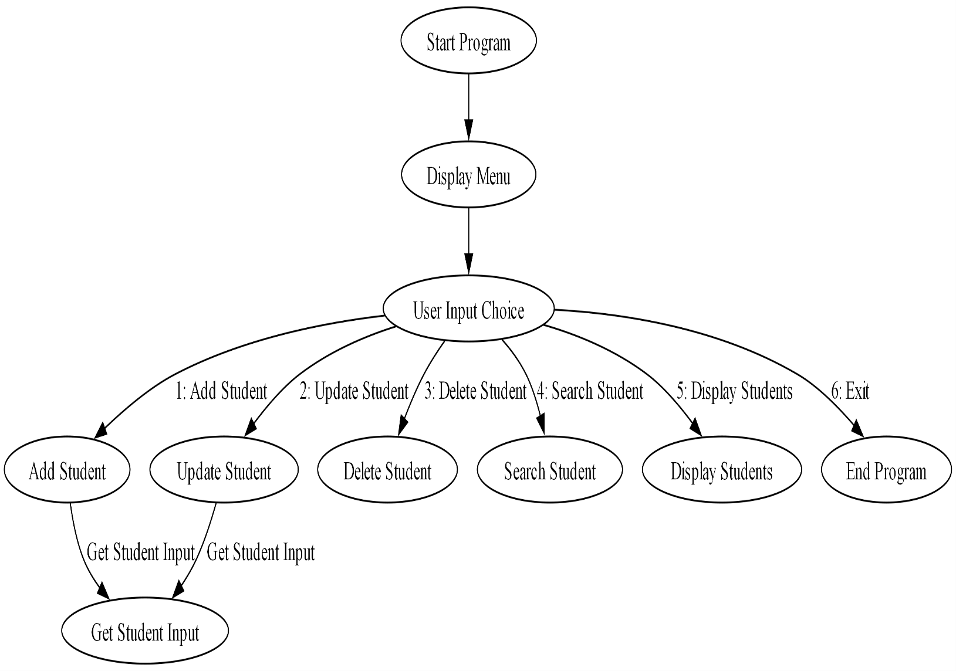

Project Code
import mysql.connector

def display_menu():
print("1. Add Student")
print("2. Update Student")
print("3. Delete Student")
print("4. Search Student")
print("5. Display Students")
print("6. Exit")

def create_database_school():
try:
connection = mysql.connector.connect(
host="localhost",
user="root",
password="admin",
)
cursor = connection.cursor()
cursor.execute('CREATE DATABASE IF NOT EXISTS school')
cursor.execute('USE school')
connection.commit()
connection.close()
except mysql.connector.Error as error:
print("Failed to connect to database:", error)

def connect_to_database():
try:
connection = mysql.connector.connect(
host="localhost",
user="root",
password="admin",
database="school"
)
print("Connected to database successfully!")
return connection
except mysql.connector.Error as error:
print("Failed to connect to database:", error)

def create_table(cursor):
table_query = """
CREATE TABLE IF NOT EXISTS student (
admno INT PRIMARY KEY,
name VARCHAR(100),
course VARCHAR(50),
fees FLOAT,
dob DATE
)
"""
cursor.execute(table_query)
print("Table created successfully!")

def add_student(connection, cursor):
admno = int(input("Enter Admission Number: "))
name = input("Enter Name: ")
course = input("Enter Course: ")
fees = float(input("Enter Fees: "))
dob = input("Enter Date of Birth (YYYY-MM-DD): ")

insert_query = f"""INSERT INTO
student(admno, name, course,fees, dob)
VALUES ({admno}, '{name}', '{course}',
{fees}, '{dob}')"""
cursor.execute(insert_query)
connection.commit()

print("Student added successfully!")

def update_student(connection, cursor):
admno = int(input("Enter Admission Number of student to update: "))

name = input("Enter Name: ")
course = input("Enter Course: ")
fees = float(input("Enter Fees: "))
dob = input("Enter Date of Birth (YYYY-MM-DD): ")
update_query = f"""
UPDATE student
SET name = '{name}', course = '{course}',
fees = {fees}, dob = '{dob}'
WHERE admno = {admno}"""
cursor.execute(update_query)
connection.commit()
if cursor.rowcount > 0:
print("Student updated successfully!")
else:
print("No student found with Admission Number:", admno)

def delete_student(connection, cursor):
admno = int(input("Enter Admission Number of student to delete: "))

delete_query = f"""
DELETE FROM student
WHERE admno = {admno}"""
cursor.execute(delete_query)
connection.commit()
if cursor.rowcount > 0:
print("Student deleted successfully!")
else:
print("No student found with Admission Number:", admno)

def search_student(cursor):
admno = int(input("Enter Admission Number of student to search: "))

search_query =f"""
SELECT * FROM student
WHERE admno = {admno}"""
cursor.execute(search_query)
result = cursor.fetchone()

if result:
print("Admission Number:", result[0])
print("Name:", result[1])
print("Course:", result[2])
print("Fees:", result[3])
print("Date of Birth:", result[4])
else:
print("No student found with Admission Number:", admno)

def display_students(cursor):
select_query = """
SELECT * FROM student
"""

cursor.execute(select_query)
result = cursor.fetchall()

if result:
for row in result:
print("Admission Number:", row[0])
print("Name:", row[1])
print("Course:", row[2])
print("Fees:", row[3])
print("Date of Birth:", row[4])
print("--------------")
else:
print("No students found.")

def main():
create_database_school()
connection = connect_to_database()
if not connection:
return

cursor = connection.cursor()
create_table(cursor)

while True:
display_menu()
choice = int(input("Enter your choice: "))

if choice == 1:
add_student(connection, cursor)
elif choice == 2:
update_student(connection, cursor)
elif choice == 3:
delete_student(connection, cursor)
elif choice == 4:
search_student(cursor)
elif choice == 5:
display_students(cursor)
elif choice == 6:
break
else:
print("Invalid choice! Please try again.")

connection.close()
print("Database connection closed.")

if __name__ == "__main__":
main()

Output
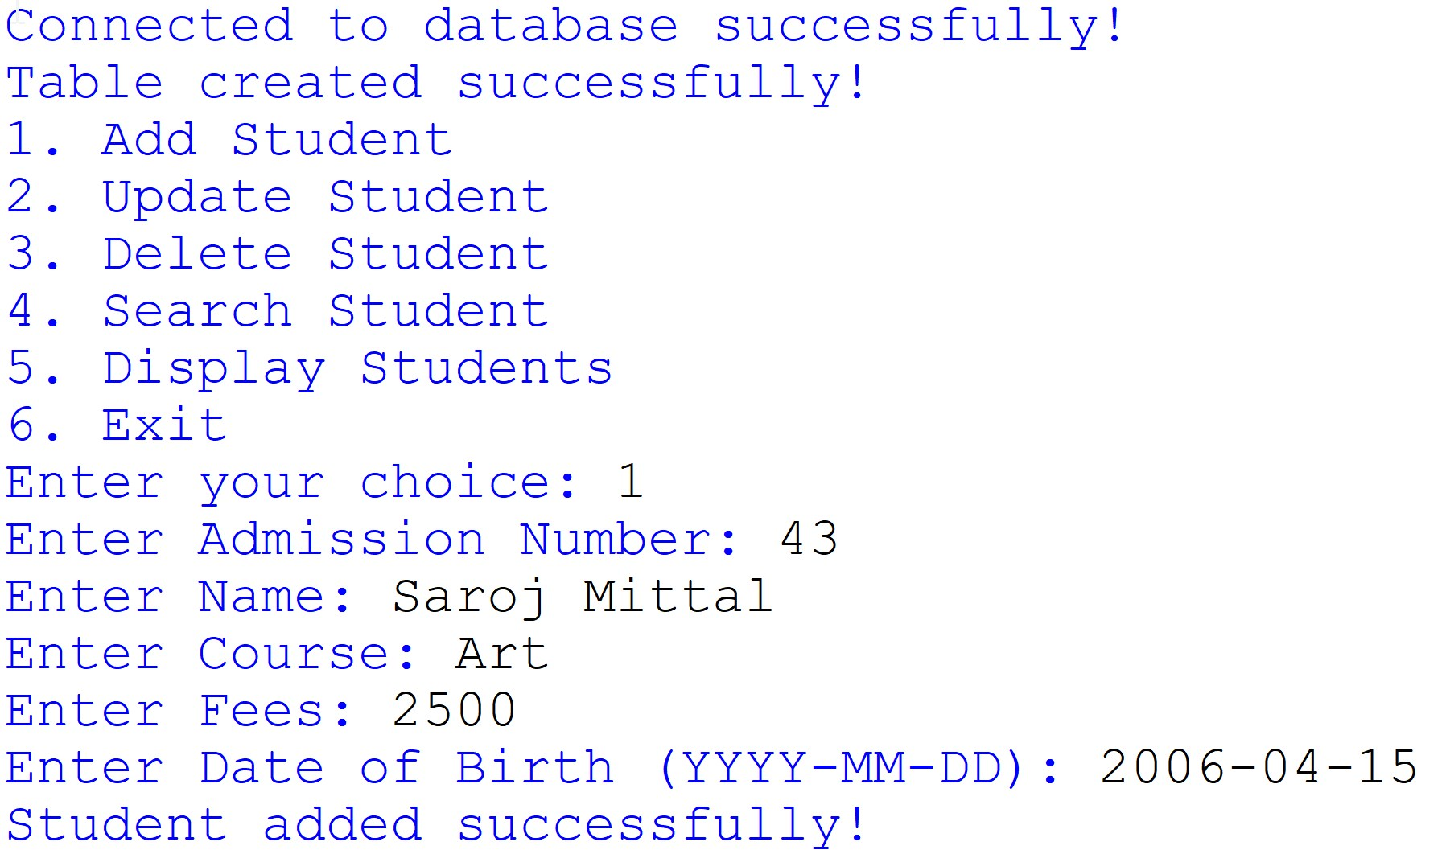
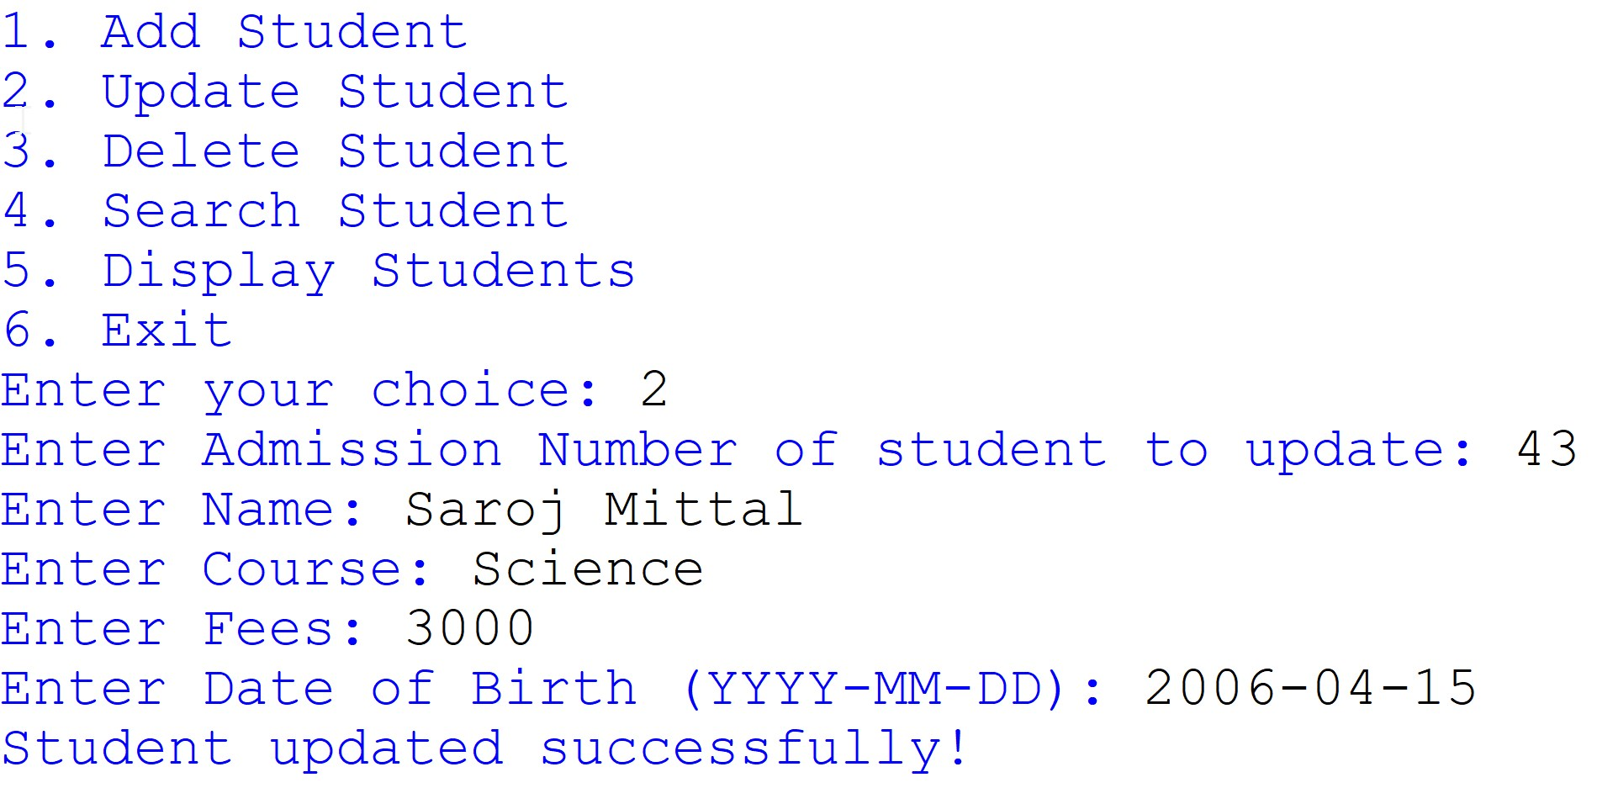

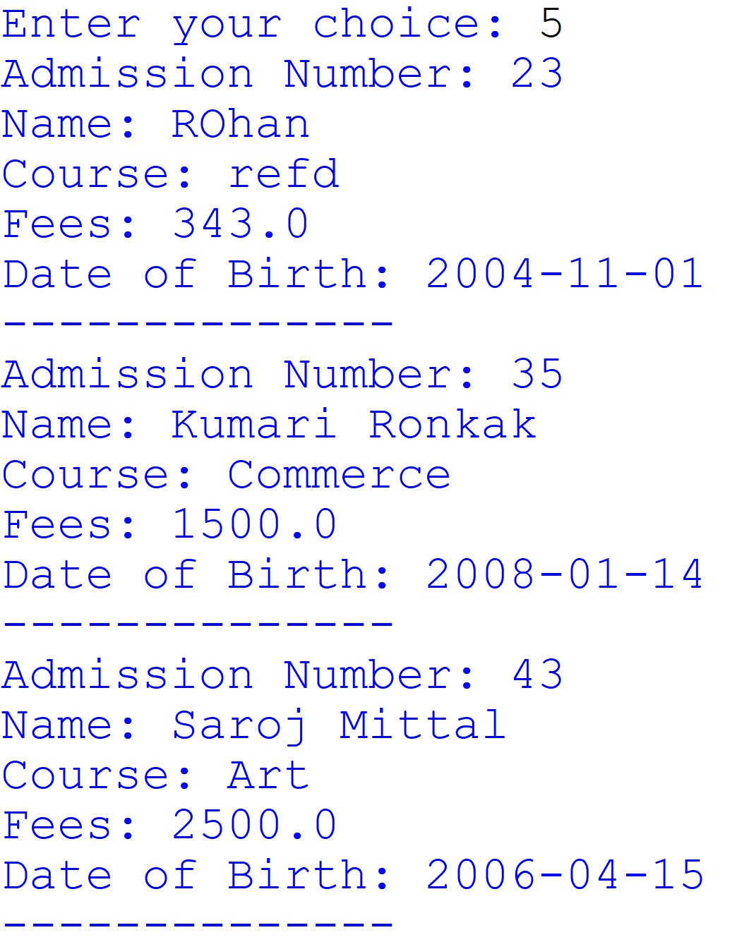
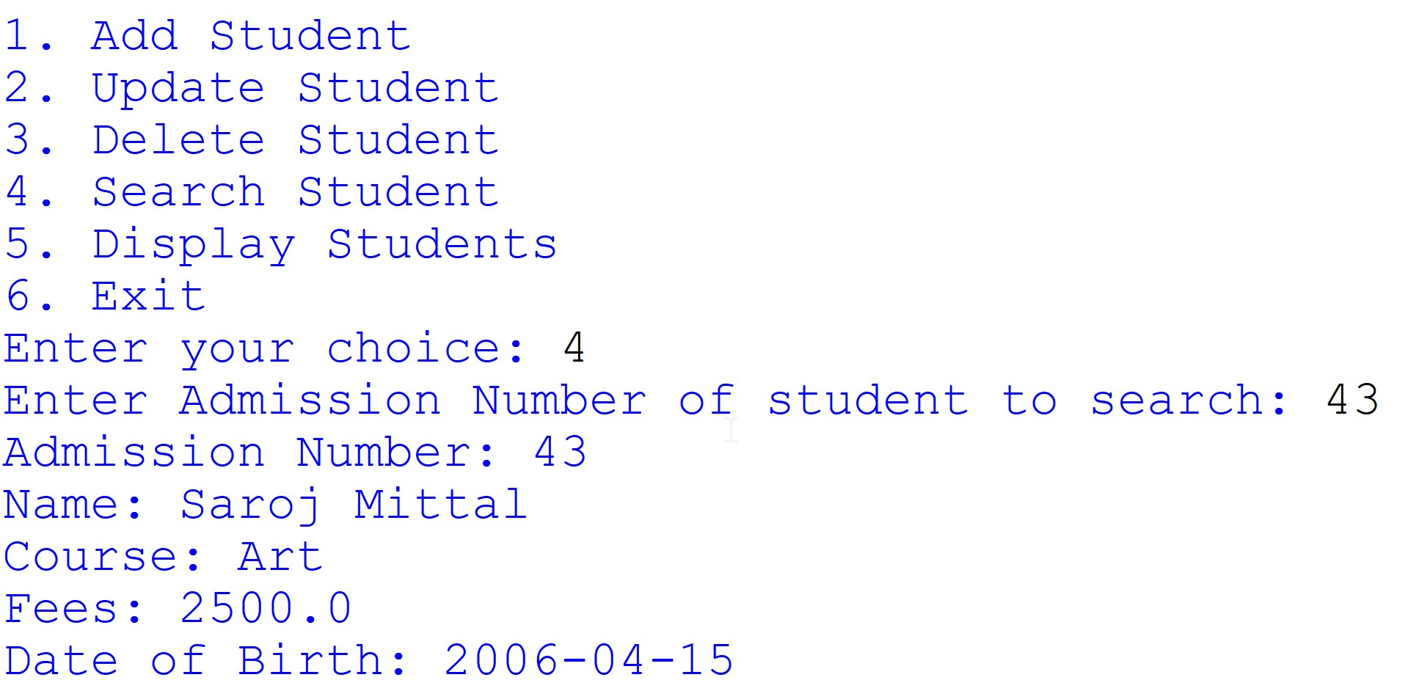
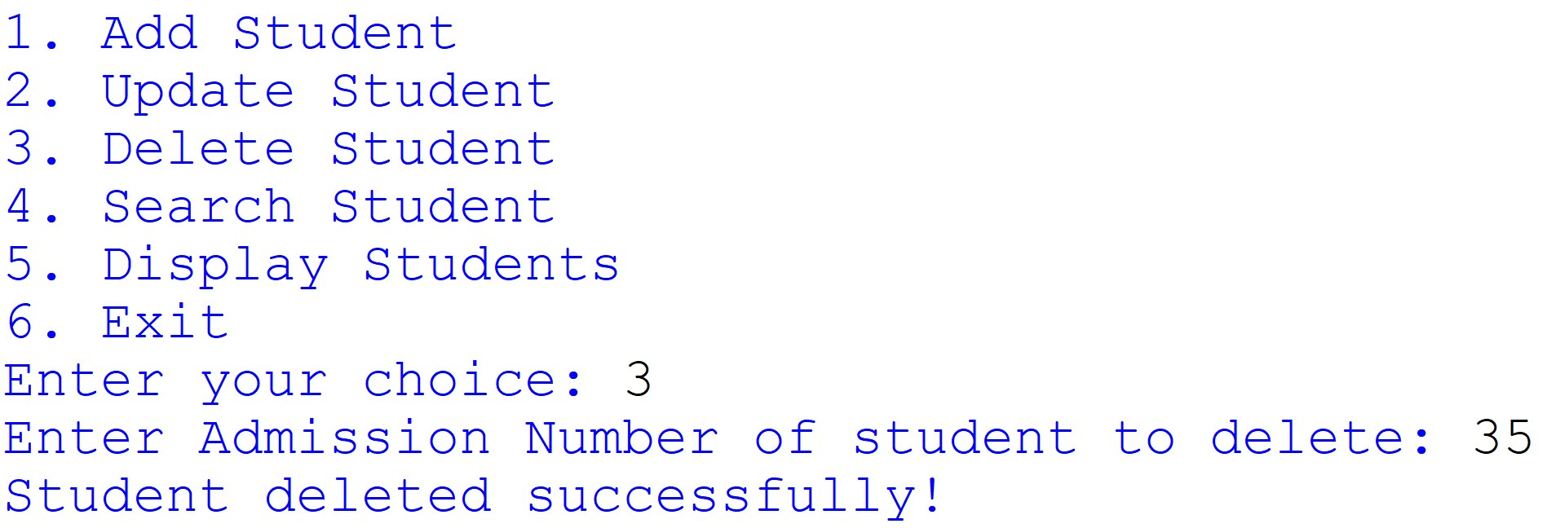

Technological requirements: Hardware & Software

Software
- Python
- VS Code
- MySQL

Hardware
- Laptop/PC

References

- https://www.python.org/
- https://www.w3schools.com/python/python_mysql_getstarted.asp
- https://dev.mysql.com/doc/connector-python/en/connector-python-example-connecting.html
- https://www.c-sharpcorner.com/blogs/crud-operations-in-python-using-mysql-database

